Kyer Potts

30003389

Database Programming AT3

Design Report

Table of Contents

Page Designs 1

Home Page 1

Suppliers Page 1

Add New Supplier Page 2

Products by Supplier Page 3

Products Page 4

Selected Product Page 5

Products by Category Page 6

Products by Supplier Page 7

Invoices Page 8

View Invoice Page 9

Customers Page 10

View Customer Page 11

Add Customer Page 12

Employees Page 13

Employee Invoices Page 14

Update Employee Info Page 15

Queries 16

Add Customer 16

Add Supplier 16

Customers 16

Employees 16

Invoices 16

Products 16

ProductsCat 17

ProductsSupp 17

Suppliers 17

UpdateEmployee 17

# Page Designs

## Home Page



## Suppliers Page

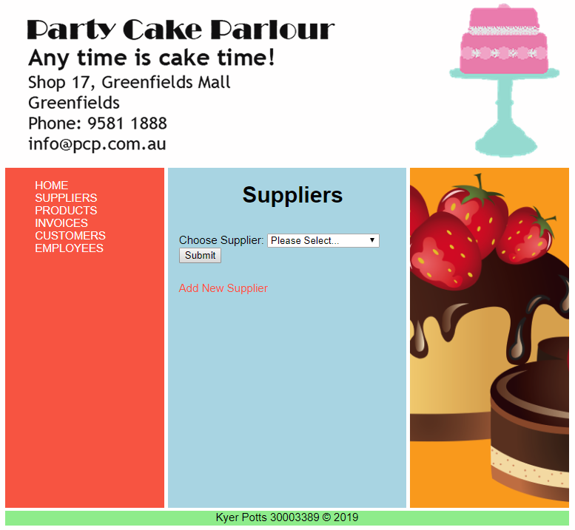

## Add New Supplier Page

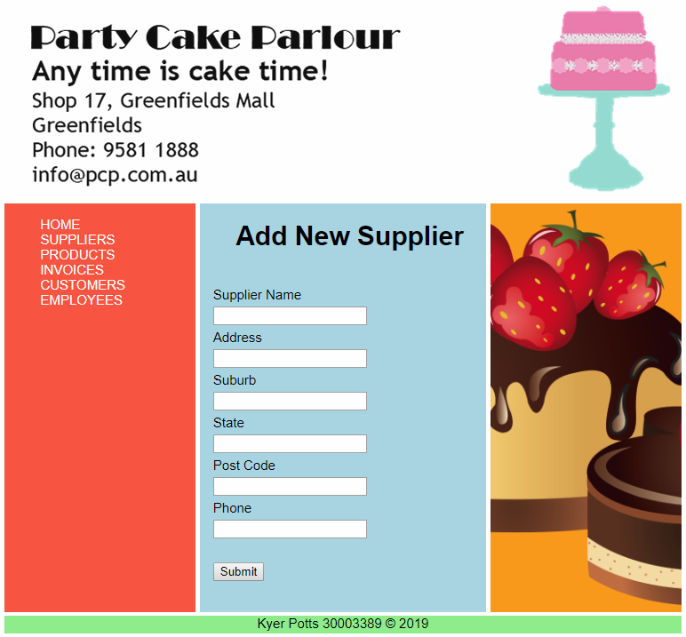

## Products by Supplier Page

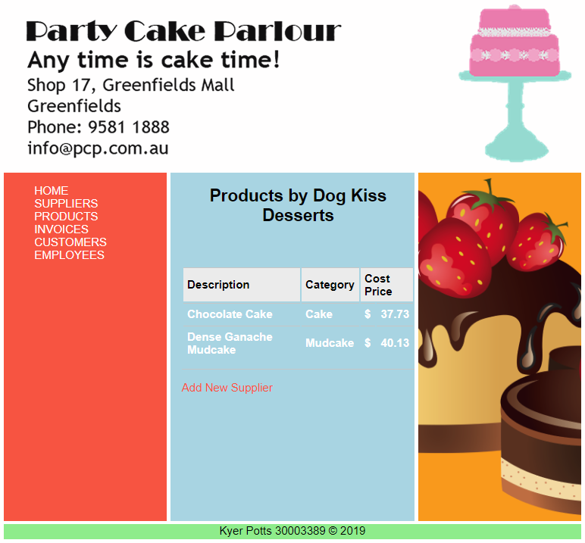

## Products Page

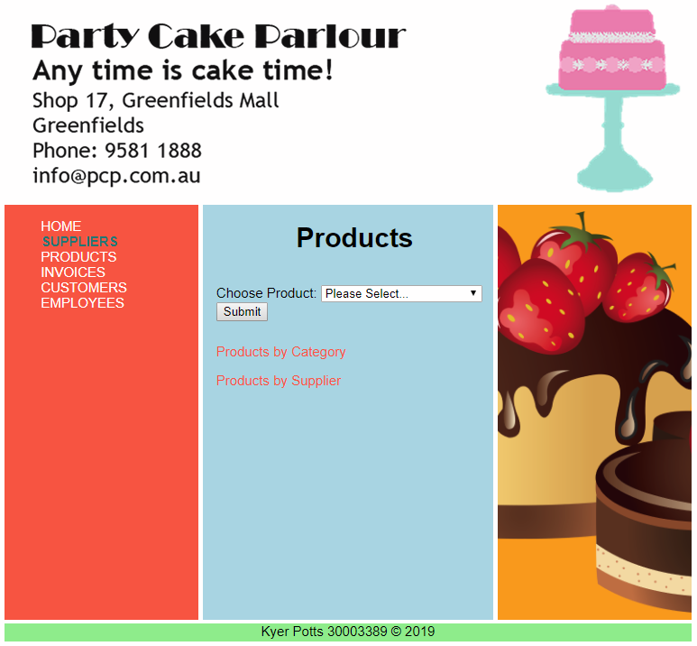

## Selected Product Page



## Products by Category Page



## Products by Supplier Page

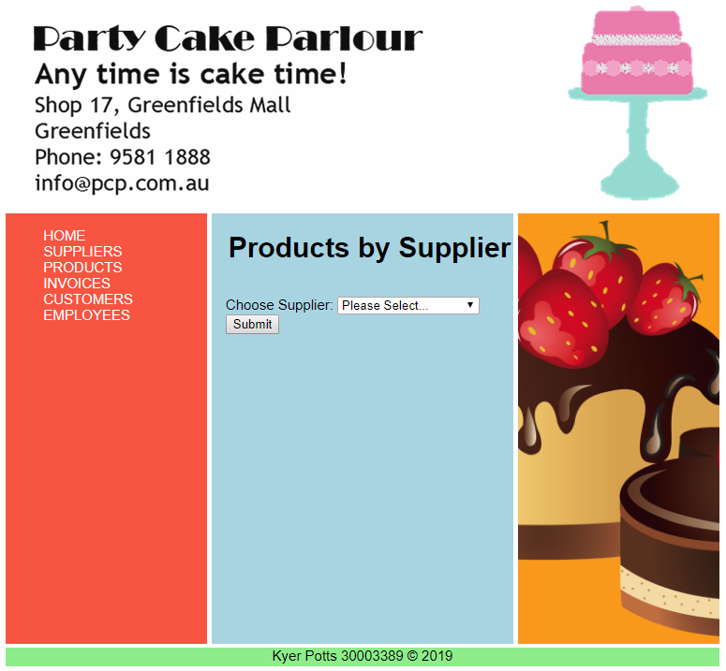

## Invoices Page

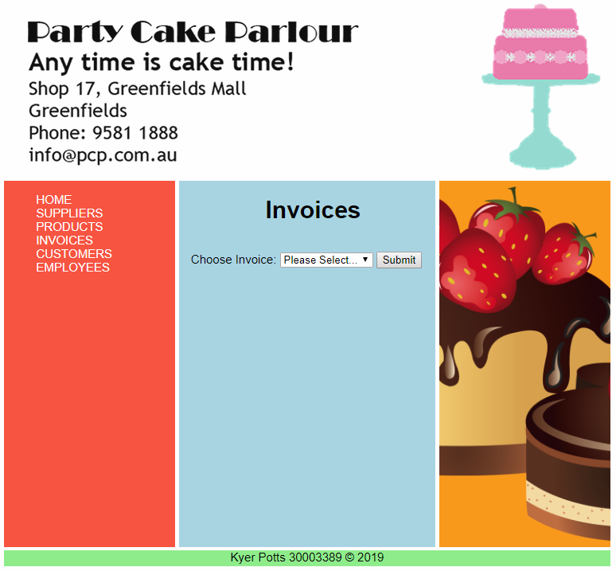

## View Invoice Page



## Customers Page

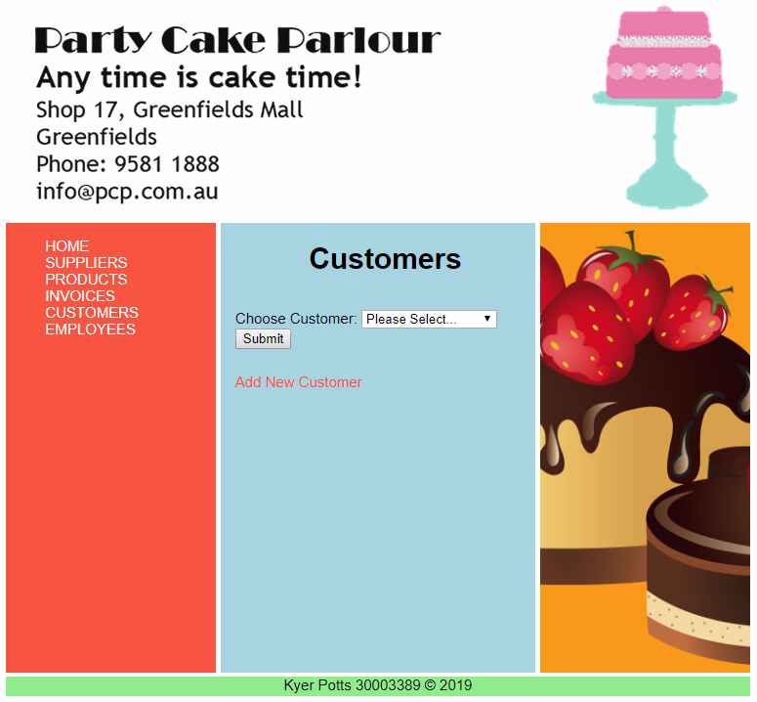

## View Customer Page



## Add Customer Page



## Employees Page



## Employee Invoices Page



## Update Employee Info Page



# Queries

## Add Customer

SELECT ID FROM customer WHERE Name = '$custf'

INSERT INTO customer

(FName, LName, Address, Suburb, State, Phone, Descr)

VALUES

('$custf','$custl', '$address', '$suburb', '$state', '$phone', '$desc' )

## Add Supplier

SELECT ID FROM supplier WHERE Name = '$supp'

INSERT INTO supplier

(Name, Address, Suburb, State, PostCode, Phone)

VALUES

('$supp','$address', '$suburb', '$state', '$postCode', '$phone')

## Customers

SELECT * FROM customer

SELECT FName, LName, Address, Suburb, State, Phone FROM customer WHERE ID = '$custID'

SELECT * FROM invoice WHERE CustID = '$custID'

## Employees

SELECT * FROM employee

SELECT FName, LName, Address, Suburb, Phone, Salary, TFN FROM employee WHERE ID = '$empID'

SELECT * FROM invoice WHERE EmpID = '$empID'

## Invoices

SELECT * FROM invoice

SELECT InvoiceNo, InvoiceDate, CustID, EmpID FROM invoice WHERE InvoiceNo = '$invID'

SELECT FName, LName, Address, Suburb, State, Phone FROM customer WHERE ID = '$cusId'

SELECT ID, FName, LName FROM employee WHERE ID = '$empId'

SELECT InvoiceNo, ProdID, Qty FROM invoice_line WHERE InvoiceNo = '$invoiceID'

SELECT Description, CostPrice FROM product WHERE ID = '$order[1]'

## Products

SELECT * FROM product

SELECT Description, CategoryID, CostPrice, SuppID FROM product WHERE ID = '$prodID'

SELECT Description from category WHERE ID = '$catId'

SELECT Name from supplier WHERE ID = '$supID'

## ProductsCat

SELECT * FROM category

SELECT Description from category WHERE ID = '$catID'

SELECT Description, CategoryID, CostPrice, SuppID FROM product WHERE CategoryID = '$catID'

SELECT Name from supplier WHERE ID = '$supID'

## ProductsSupp

SELECT * FROM supplier

SELECT Name from supplier WHERE ID = '$suppID'

SELECT Description, CategoryID, CostPrice FROM product WHERE SuppID = '$suppID'

SELECT Description from category WHERE ID = '$catId'

## Suppliers

SELECT * FROM supplier

SELECT Name from Supplier WHERE ID = '$suppID'

SELECT Description, CategoryID, CostPrice FROM Product WHERE SuppID = '$suppID'

SELECT Description from category WHERE ID = '$catId'

## UpdateEmployee

SELECT ID FROM employee WHERE FName = '$empf'

UPDATE employee

SET (FName = '$empf', LName = '$empl', Address = '$address', Suburb = '$suburb', Phone = '$phone', Salary = '$salary',TFN = '$tfn')

WHERE employee ID = '$check'